IHCA Pre-Budget Health Sector Submission

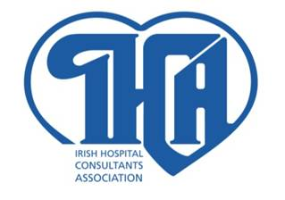

September 14th, 2010

IRISH HOSPITAL CONSULTANTS ASSOCIATION
HERITAGE HOUSE TELEPHONE: 298 9123
DUNDRUM OFFICE PARK FAX: 298 9395
DUBLIN 14 e-mail: info@ihca.ie
Website: www.ihca.ie
Health Budget Underfunding
- Based on the increasing demand for health services and the underfunding in recent years, the budget funding for acute hospitals and mental health services should be increased in 2011 and not reduced as seems to be proposed by the Government.

- HSE Budgets and National Service Plans have over the past four years (1997-2010) underestimated the demand for health services resulting in restrictions on service delivery and patient care due to insufficient funding. These restrictions have seriously undermined the capacity of acute hospitals and mental health services to provide the level of care required for an ageing population.

- The 2010 HSE Budget was cut by over €1billion consisting of an estimated €400m non-pay cut and €659m in salary cuts.

- In 2007 and 2008 the HSE Budget was underfunded by around €250m per annum. In 2009 the HSE Budget was underfunded by €540m requiring a €260m supplementary budget in April 2009 and additional cuts totaling €280m.

2010 Over Budget Position
- The HSE July 2010 Performance Report dated September 9th, 2010 confirmed the following negative effects of the 2010 Budget underfunding:

- In July, the HSE expenditure was €35m (0.5%) over budget, equivalent to a €60m overrun if service levels and spending continue at that level for the full year.

- The HSE Regional Budgets, which fund the integrated acute hospital and primary and community services, were collectively €140m over budget in July, equivalent to underfunding of €241m (2.7%) on a full year basis.

- The overspend per region is the highest in the West (3.7%) and Dublin North-East (3.7%), followed by the South (1.9%) and Dublin Mid-Leinster (1.9%)

- Acute hospital funding has proven to be most underfunded with a 4.8% overspend of €110m in the first seven months of the year. This overspend is equivalent to €189m on a full year basis if services are maintained at the level required to meet patient demand, further highlighting the extent of underfunding in the critically important acute hospital services.

- The extent and the regional impact of the acute hospitals underfunding are apparent below, in particular in the West which is underfunded to the tune of 9.1 % based on the July 2010 figures.

July 2010 Acute Hospital Services Budget by Region
Region | Budget  Overspend | Over Budget  (Underfunding)
West  South | €44.8m  €17.3m | 9.1%  3.7%
Dublin North East | €28.1m | 5.5%
Dublin Mid Leinster | €19.5m | 2.4%
Total | €110m | 4.8%
Source: HSE July 2010 Performance Report
- The Mental Health Budget was reported by the HSE as 1.5% over budget on July 31st, equivalent to underfunding of €10m on a full year basis.

- The combined 2010 budget underfunding for acute hospitals and mental health services is estimated to be around €200m on a full year basis, taking account of the outcome on the first seven months of 2010.

Increasing Demand for Public Health Services
- Demand for healthcare services, including acute hospital care and mental health services, has increased steeply in the last decade due to an ageing and increasing population and the projections are that the demand will continue to increase into the foreseeable future.

- This increase in demand is exacerbated by the 42,000 (1.8%) reduction in the numbers with private health insurance in the 12 months to June 2010.

Insufficient Acute Hospital Beds
- The 2009 published OECD Report confirms:
  - Ireland has significantly fewer acute hospital beds than most other OECD countries at 2.7 acute beds per 1,000 of population compared with 3.8 acute beds per 1,000 of population in the OECD on average; and
  - The average length of stay in an acute hospital in Ireland was 5.9 days which is below the OECD average of 6.5 days.

- Despite the above compelling statistics, Irish acute public hospital beds were cut by 900 in 2009 and the HSE plans to close a further 1,100 acute hospital beds in 2010. Over the two years the HSE proposes to cut the number of acute hospital beds by 2,000 or an estimated 17%. These reductions were to be facilitated on the basis that community and co-located private hospital beds would be increased significantly to reduce demand for acute public hospital services, but this has not occurred. Therefore the reduction in acute beds is leading to much reduced capacity in acute hospitals in the face of increasing demand. At the end of July 2010, 966 beds were unavailable for discharge, of which 762 are described as planned bed reductions. In addition, a significant number of beds are blocked to new patients because clinically discharged patients have not been provided with facilities appropriate to their needs.

Mental Health Services
- Mental Health expenditure up to July 31st is reported as totaling €411m, 1.5% over budget. This is equivalent to €10m underfunding on a full year basis if services are maintained at the level required to meet patient demand.

- Child and adolescent waiting lists totaled 2,779 on the July 31st Performance Report.

- There is a serious concern that the staff embargo and staff cuts are disproportionately impacting on the delivery of mental health services and the development and expansion of community based mental health services, which require increased staff levels. For instance over 600 psychiatric nurses have left the service in the past year.

- Of particular concern, the 2010 €50m capital budget for mental health facilities, arising from the sale of surplus assets, is unlikely to be spent as planned during the year. The July 31st Performance Report confirmed that the expenditure to date totaled €10.7m, some 50% below target.

- Overall, there is a lack of transparency in the HSE performance and other reports on the resourcing and funding provided for mental health services. Mental Health over the years has suffered from the continual erosion of funding. The HSE Mental Health budget amounts to about 5.3% of the overall HSE Budget, which is well below the 8.4% recommendation included in Vision for Change.

Budget and the HSE National Service Plans Underestimate Demand
- Acute hospital service delivery has consistently exceeded the targets included in the annual HSE National Service Plans for inpatient, day care and outpatient attendances, as illustrated in the graph below comparing the NSP target and actual in-patient activity in 2008 and 2009. Statistics on a month to month basis are not available from the HSE for 2010, but the indicators confirm that same trend has continued in 2010 as illustrated in the graph below.

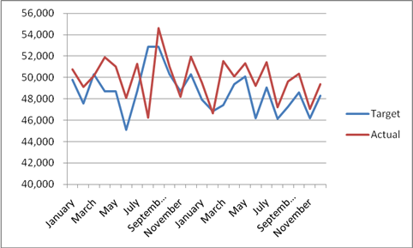
Source: IHCA based on HSE performance report data

- The 2010 HSE proposal to reduce in-patient numbers by 54,000 in 2010 (-9.1% compared with the 2009 outturn) is highly questionable given demand levels and the reduction of 7,775 (-1.3%) achieved in 2009. The 2010 activity figures to July 31st confirm that inpatient and day case discharges are 24,124 (+7.6%) and 27,639 (+6.9%) respectively above the July 31st targets in the National Service Plan.
Hospital Service Outturns Compared with the HSE National Service Plan Targets
 | 2007 | 2008 | 2009 | 2010*
In-Patient Discharges | +2.5% | +1.7% | +3.5% | +7.6%
Day cases | +2.5% | +7.9% | +4.3% | +6.9%
Emergency Presentations | +5% | +3.3% | - 3.3% | N/A
Emergency Admissions | +3% | -0.3% | -0.4% | +9.9%
Outpatient Attendances | +9% | +18.0% | +3.1% | +2.6%
Births (Year on Year) | +10% | +5.3% | +1.1% | -1%
Sources: IHCA based on HSE Performance Reports including the July 2010 Performance Report dated September 9th. (* 2010 figures based on July 2010 outcome compared with YTD targets).

- Overall, the actual number of patients treated in public hospitals increased by an estimated 2.2% in 2009 compared with 2008, as outlined in the table below. The July 2010 activity figures below confirm a 4.5% or 123,199 increase in the number of in-patient, day case, and out-patients treated in acute hospitals up to July 31st compared with the same period in 2009. This increase has occurred despite reductions in bed and other resources because of the population’s increased need for health services.

Actual Acute Hospital Activity
 | 2008 | 2009 | Variance July July Variance  09/08 2009 2010 10/09
In-Patient Discharges | 601,134 | 593,359 |  | -1.3% 349,587 343,009 -1.9%
Day cases | 629,758 | 674,949 |  | +7.2% 388,911 427,723 +10%
Sub-Total | 1,230,892 | 1,268,308 |  | + 3.0% 738,498 770,732 +4.4%
Out-patients | 3,271,665 | 3,334,585 |  | +1.9% 1,986,299 2,077,684 +4.6%
Births | 73,815 | 74,602 |  | +1.1% 43,197 42,777 -1%
Overall Total | 4,576,372 | 4,677,495 |  | +2.2% 2,767,994 2,891,193 +4.5%
Source: IHCA based on HSE Performance Reports dated 11th February 2010 and September 9th, 2010.
- Given this increased acute hospital activity and because of the 2010 budget underfunding most acute hospitals were well over budget on July 31st including the following examples:

- University College Hospital, Galway €14.7m
- Mid-Western Regional Hospital, Limerick €12m
- Beaumont Hospital €7.8m
- Our Lady of Lourdes Hospital, Drogheda €7.1m
Adelaide and Meath Hospital, Tallaght €6.4m
Bed, Theatre and other Capacity Reductions
- Senior HSE management has confirmed that the impact of the reduced 2010 budget will be that breakeven plans for all hospitals will involve bed closures, resulting in longer waiting times in hospital emergency departments. Prof Brendan Drumm in his July 8th report to the Board confirmed that comprehensive breakeven plans for each region were put in place at the start of this year. He added that based on the May financial data the regional breakeven plans were subject to a significant review and the plans were currently being augmented as the scale of the challenge is significant in all regions. Furthermore, he confirmed that a particular and concerted focus is being placed on the West to deal with the financial challenges there amounting to €88m.

- The reductions in 2010 Budget give rise to grave concerns as they will force budget driven reductions in the long term capacity to deliver acute hospital care and mental health services to the detriment of patient care and safety in an era of increasing demand for healthcare.

- Underfunding to date and restrictions on service delivery have resulted in:
  - The closure of acute hospital services, hospital beds, wards, theatres and other facilities essential for service delivery;
  - Increased waiting lists, which have totaled around 46,000 inpatient and day-case patients;
  - Increased reliance on trolleys and chairs in emergency departments due to a lack of beds to admit patients; and
  - Excessive patient waiting times in many emergency departments where patients have to endure delays in treatment and admission.

- Bed closures, for example, include: Beaumont, 52 beds in May; Mater, 60 beds in June; Dundalk and Drogheda, 35 beds in July; Cavan: 28 beds planned in September/October and Mid-Western Regional Hospital, 40 beds.

- Theatre closures, for example, include: Letterkenny closed for 3 weeks during the Summer; Cork University Hospital rolling Summer theatre closures; Waterford Regional Hospital 3 theatres closed for July and August; Mullingar Hospital educed elective services during the Summer; Mater Hospital rolling theatre closures during the Summer; Galway University Hospital rolling theatre closures during the Summer and Mid-Western Regional Hospital will have half the theatres closed over the next 3 months.

- The delivery of Home Help Hours declined by 7% up to July 31st and older people in public long stay facilities are being encouraged to apply to Fair Deal and to transfer to Private Nursing Homes.

Increases in Waiting Lists, Use of Trolleys and Emergency Delays

- The most recent HSE Performance Report confirms over 46,000 children and adults are waiting for treatment (see table below). This represents a large number of patients in July 2010, who were experiencing significant delays in receiving treatment which is leading to suffering and deterioration in patient conditions which may affect their recovery. It represents a 16% increase in the numbers on waiting lists compared with the year earlier position.

Waiting lists
 | In-patient |  | Day Case |  | Totals
 | Children | Adults | Children | Adults | Children | Adults
New Hospital Referrals 0-3 months | (960)  975 | (6,374)  6,474 | (1,198)  1,446 | (12,900)  17,795 | (2,158)  2,421 | (19,276)  24,269
National Waiting List  (+3 months) | (1,376)  1,158 | (7,013)  6,599 | (1,914)  1,481 | (8,383)  10,532 | (3,290)  2,639 | (15,396)  17,131
Totals | (2,336)  2,133 | (13,389)  13,073 | (3,112)  2,927 | (21,283)  28,327 | (5,448)  5,060 | (34,672)  41,400
Grand Total | (15,725)  15,206 |  | (24,395)  31,254 |  | (40,120)  46,460
% 2009 Targets  % 2010 Targets | (2.7%)  2.8% |  | (3.8%)  4.5% |  | (3.3%)  3.8%
Source: HSE Performance Report 8th October 2009: August 2009 figures in brackets.
HSE Performance Report 9th September 2010: July 2010 figures not in brackets.
- Outpatient Waiting Lists
In addition to the increased demand for in-patient and day case care, there is a strong increase in the demand for out-patient consultations as illustrated in the ESRI published projection in the graph below. Currently, the HSE does not publish statistics on the number of patients awaiting out-patient consultations although it is clear there are lengthy and increasing waiting lists and times in many specialties.

Projected increase in Outpatient Consultations by Hospital Network 2006 - 2021
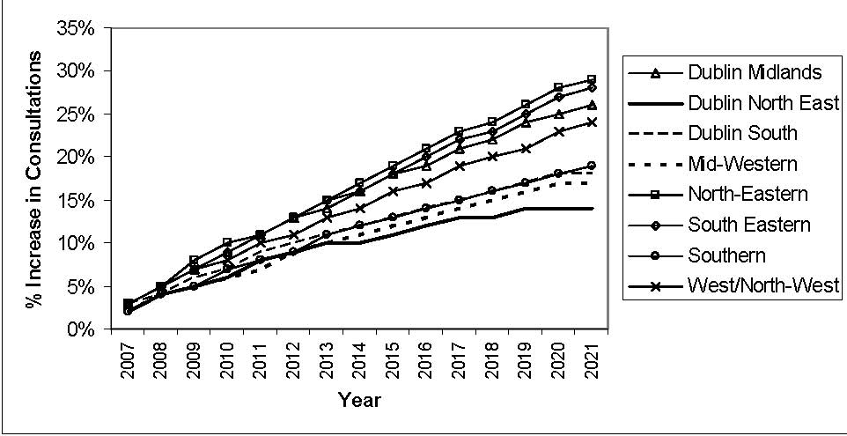
Source: ESRI Research Series 13, October 2009

- Unacceptable Trolley Use in Emergency Departments
Due to the shortage of inpatient and other beds, a large and unacceptable number of patients who are deemed admitted to hospital are required to be treated on trolleys and chairs in emergency departments as boarders, despite the negative effects this has on patient care and the fire and other safety breaches it creates. The effects of the cramped conditions include poorer patient outcomes, increased levels of hospital acquired infections and compromised patient dignity as they have to be treated often in public corridors.

The INMO Trolley count totalled 70,116 in acute hospital emergency departments over the 12 month period up to August 31st, 2010. This represents an 11% increase on the previous year’s trolley count, reflection the deterioration acute hospital resources and increasing demand. It is estimated that the commissioning of several hundred acute hospital beds are required just to remove the need for admitted patients to be treated on trolleys.

IHCA Budget Recommendations

- The IHCA strongly recommends that the 2011 HSE Budget needs to be fully resourced to meet the patient demand for healthcare services, especially in the underfunded acute hospital and mental health budgets. It is vitally important that the Health Budget is funded properly because access to healthcare is a basic human right that should be prioritised over the need to achieve reductions in public expenditure, even in a recession.

- There is a serious concern that reduced funding and resources, which are based on underestimates of demand, will give rise to even greater service restrictions in 2011 if the HSE Budget is not funded properly to reflect the increasing demand for publicly funded health services arising from demographic and health insurance changes.

- The Government suggestion that it is planning to reduce the 2011 Health Budget would be extremely damaging if implemented in frontline acute hospitals and mental health services given the combined effects of recent cuts.

The IHCA recommends that the 2011 Budget should increase the funding for frontline acute hospital and mental health services compared with the 2010 budget provisions.

The detailed IHCA recommendations are that the acute hospital and mental health budgets should be based on the following considerations:

- Shortfalls

Shortfalls in the 2010 Budget need to be provided for in the 2011 Budget. In particular, the July 31st, 2010 deficits in the acute hospital and mental health budgets must be funded in the 2011 Budget, so that services are maintained at the level required to meet patient demand, without the imposition of augmented breakeven plans which reduce services in the last few months of the year such as are being implemented in 2010.

- Provisions for increased service demand and delivery.

It is expected that increased service demand and delivery will arise in 2011 as has occurred in recent years, including 2010.

      - Increased Demand.

Reflecting the impact of an ageing population, it is probable that service demand will increase by around 2% in acute hospitals because of these demographic factors.

(b) Reducing Waiting Lists

Provision needs to be made in the Budget for the cost of at least halving the waiting list for inpatient and day case services, which are equivalent to 3.8% of the 2010 HSE NSP targets.

(c) Reduced the Use of Trolleys

The INMO Trolley Watch totaled 70,116 in the past 12 months. It is estimated that an increase of several hundred in in-patient hospital and day case beds is required to end the inappropriate use of trolleys and chairs for inpatient care.

- Increased Public Health Demand due to Reductions in Private Health Insurance.

A reduction of 42,000 people with private health insurance has occurred in the 12 months to June 2010 representing a decline of 1.8% in private insurance cover. The equivalent increase in the numbers relying on public healthcare is about 2%.

(e) Mental Health Services.

The overall funding for Mental Health services should be increased significantly. Increased demand for mental health services and the requirement to develop and expand community based mental health services increases staff and other costs. Increased capital funding is required to facilitate community based services and the provision of separate child and adolescent psychiatric accommodation.

- Unsustainable Cuts
Once off revenue increasing parts of the 2010 Budget, such as the €75m to be collected through speedier collection of health insurance fees, must be provided for in the 2011 Budget.

Conclusion
The IHCA strongly recommends that funding for the delivery of frontline acute hospital and mental health services should be increased, taking account of increasing demand and other factors outlined in this submission.

